**CS 131 C# - Beginner**

**HOP01A –Visual Studio Community 2019**

11/16/2019 Developed by Apiwat Chuaphan

12/26/2019 Reviewedby Kim Nguyen

Center for Information Assurance (CIAE) @City University of Seattle (CityU)

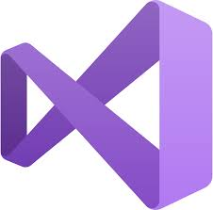

**Before You Start**

* If you already finished this module through other CityU School of Technology and Computing (STC) courses, feel free to skim this activity. But verify VS installation on your computer.
* Version numbers may not match with the most current version at the time of writing. If given the option to choose between stable release (long-term support) or most recent, please choose the stable release rather than beta-testing version.
* This tutorial targets Windows users and MacOS users.
* There might be subtle discrepancies along the steps. Please use your best judgement while going through this cookbook style tutorial to complete each step.
* For your working directory, use your course number. This tutorial may use a different course number as an example.

**Learning Outcomes**

* Installing Visual Studio
* Making your development directory

**Resources**

* Visual Studio tutorials | C# - <https://docs.microsoft.com/en-us/visualstudio/get-started/csharp/?view=vs-2019>

**Installing Visual Studio**

**Windows**

1. Download (**Community Version**) - <https://visualstudio.microsoft.com/downloads/>
2. It will ask you to acknowledge the Microsoft License Terms and the Microsoft Privacy Statement. Choose Continue.

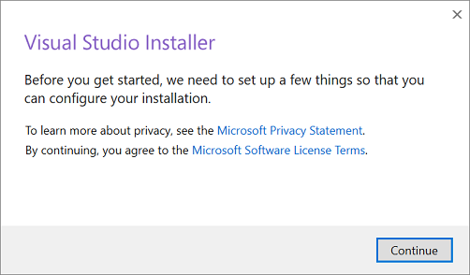

1. After the installer is installed, you can use it to customize your installation by selecting the feature sets—or workloads—that you want. For example, choose ASP.NET and .NET development.

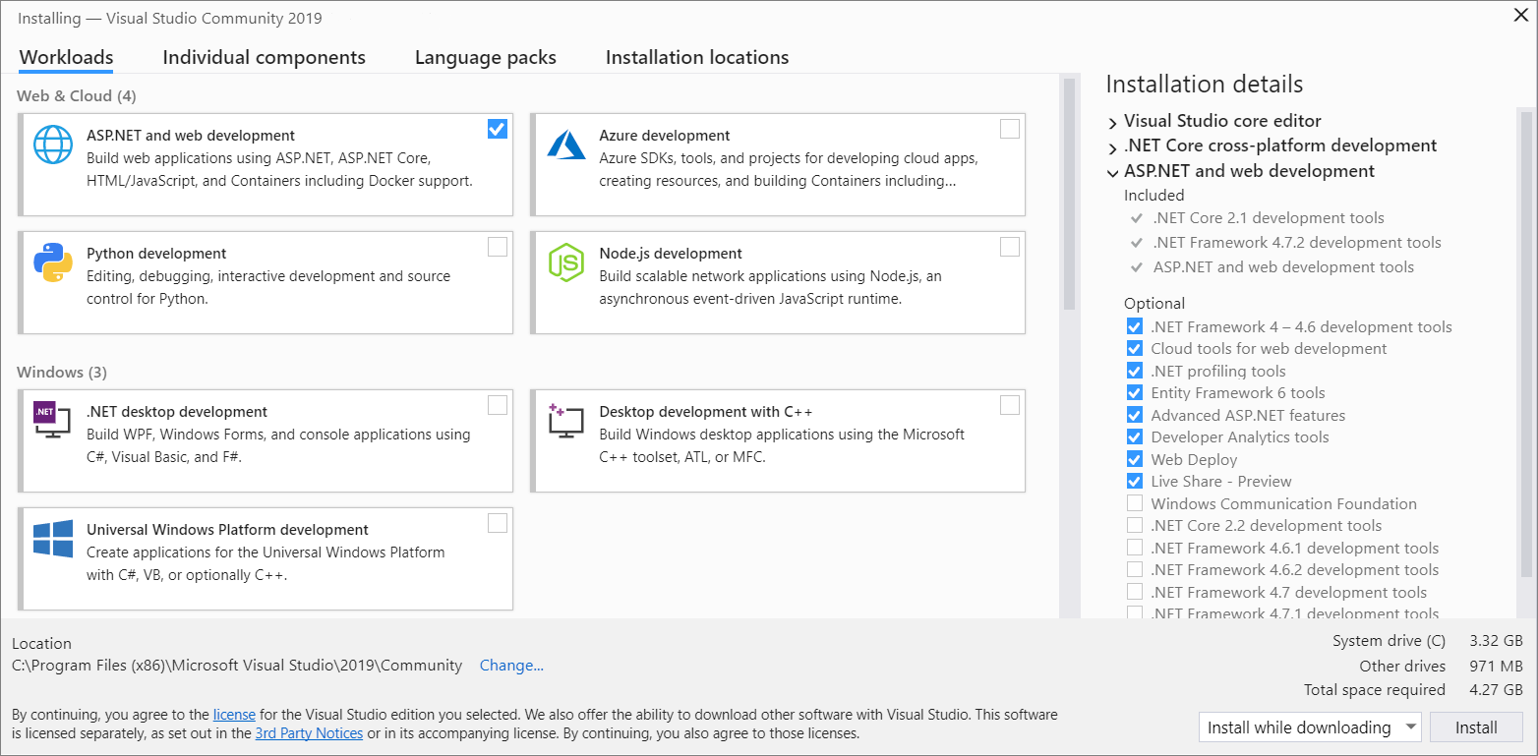

1. After Visual Studio installation is complete, choose the Launch button to get started developing with Visual Studio.
2. On the start window, choose Create a new project. (File > New > Project)

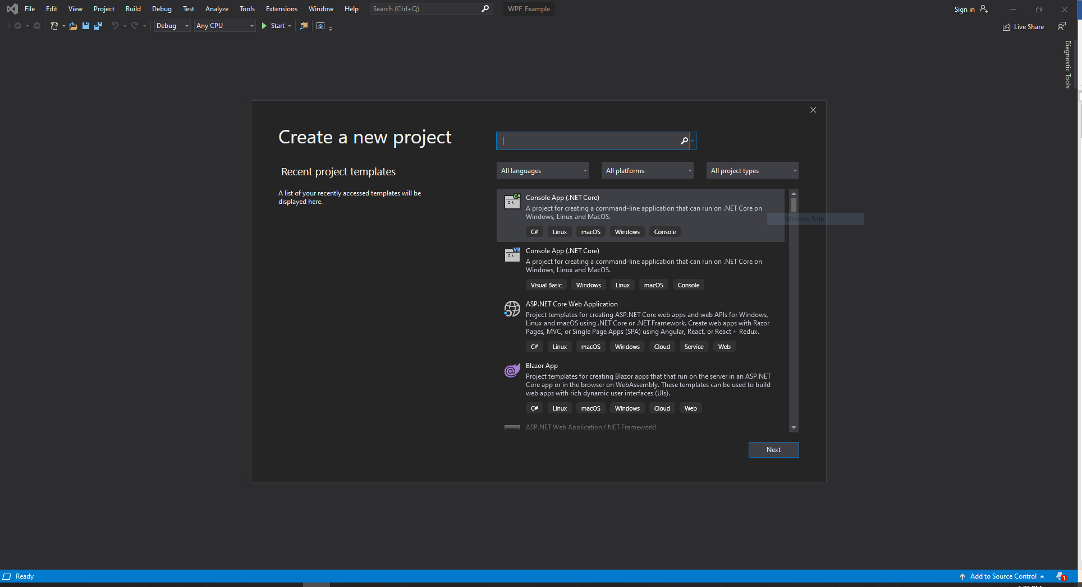

**Additional VS installation tutorial**

* + Mmtuts. (2019). Installing Visual Studio | Setup Our First Project | C# Tutorial For Beginners | C Sharp Tutorial <https://www.youtube.com/watch?v=nbbIesdfCSI&list=PL0eyrZgxdwhxD9HhtpuZV22KxEJAZ55X-&index=2>

**MacOS**

1. Download (**Community Version**) - <https://visualstudio.microsoft.com/downloads/>
2. Once the download is complete, click the **VisualStudioforMacInstaller.dmg** to mount the installer, then run it by double-clicking the arrow logo.

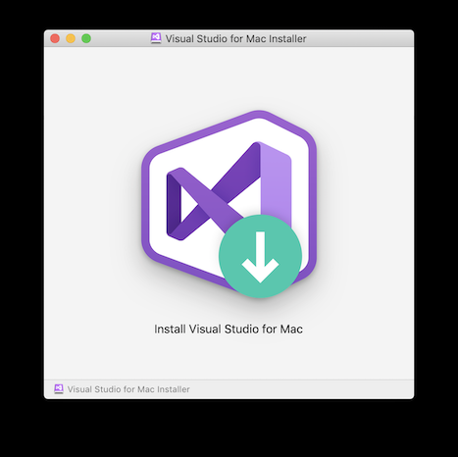

1. You may be presented with a warning about the application being downloaded from the Internet. Click Open.
2. An alert will appear asking you to acknowledge the privacy and license terms. Follow the links to read them, then press Continue if you agree.

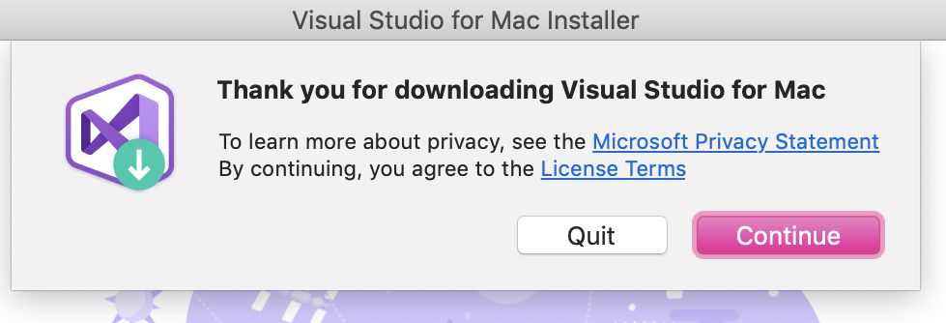

1. The list of available workloads is displayed. Select the components you wish to use.

* Select **.NET Core platform** for **.NET Core applications** and **ASP.NET Core Web Applications**

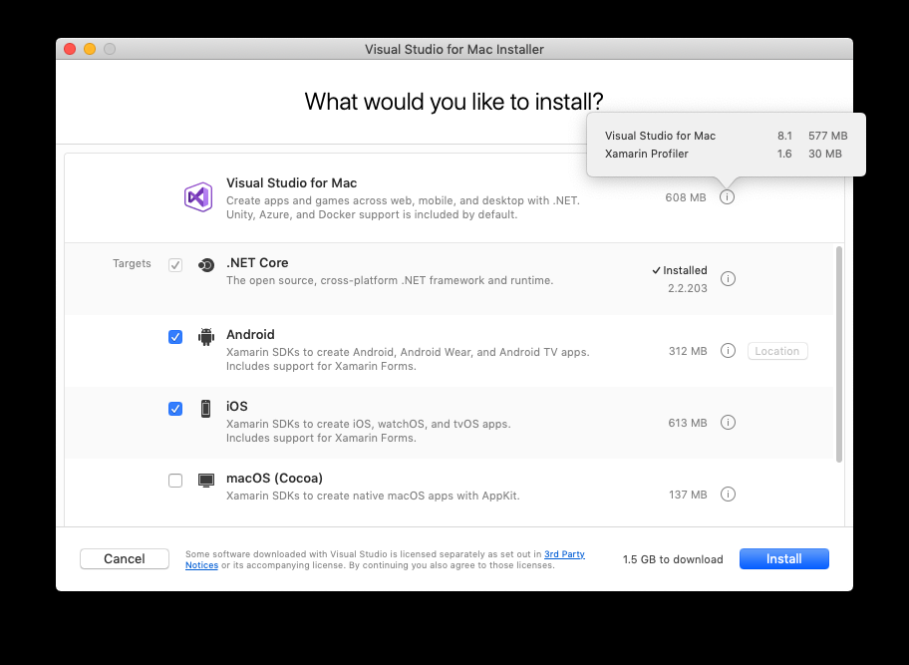

1. Press Install button and Once installed, Visual Studio for Mac will prompt you to personalize your installation by signing in and selecting the key bindings that you'd like to use.

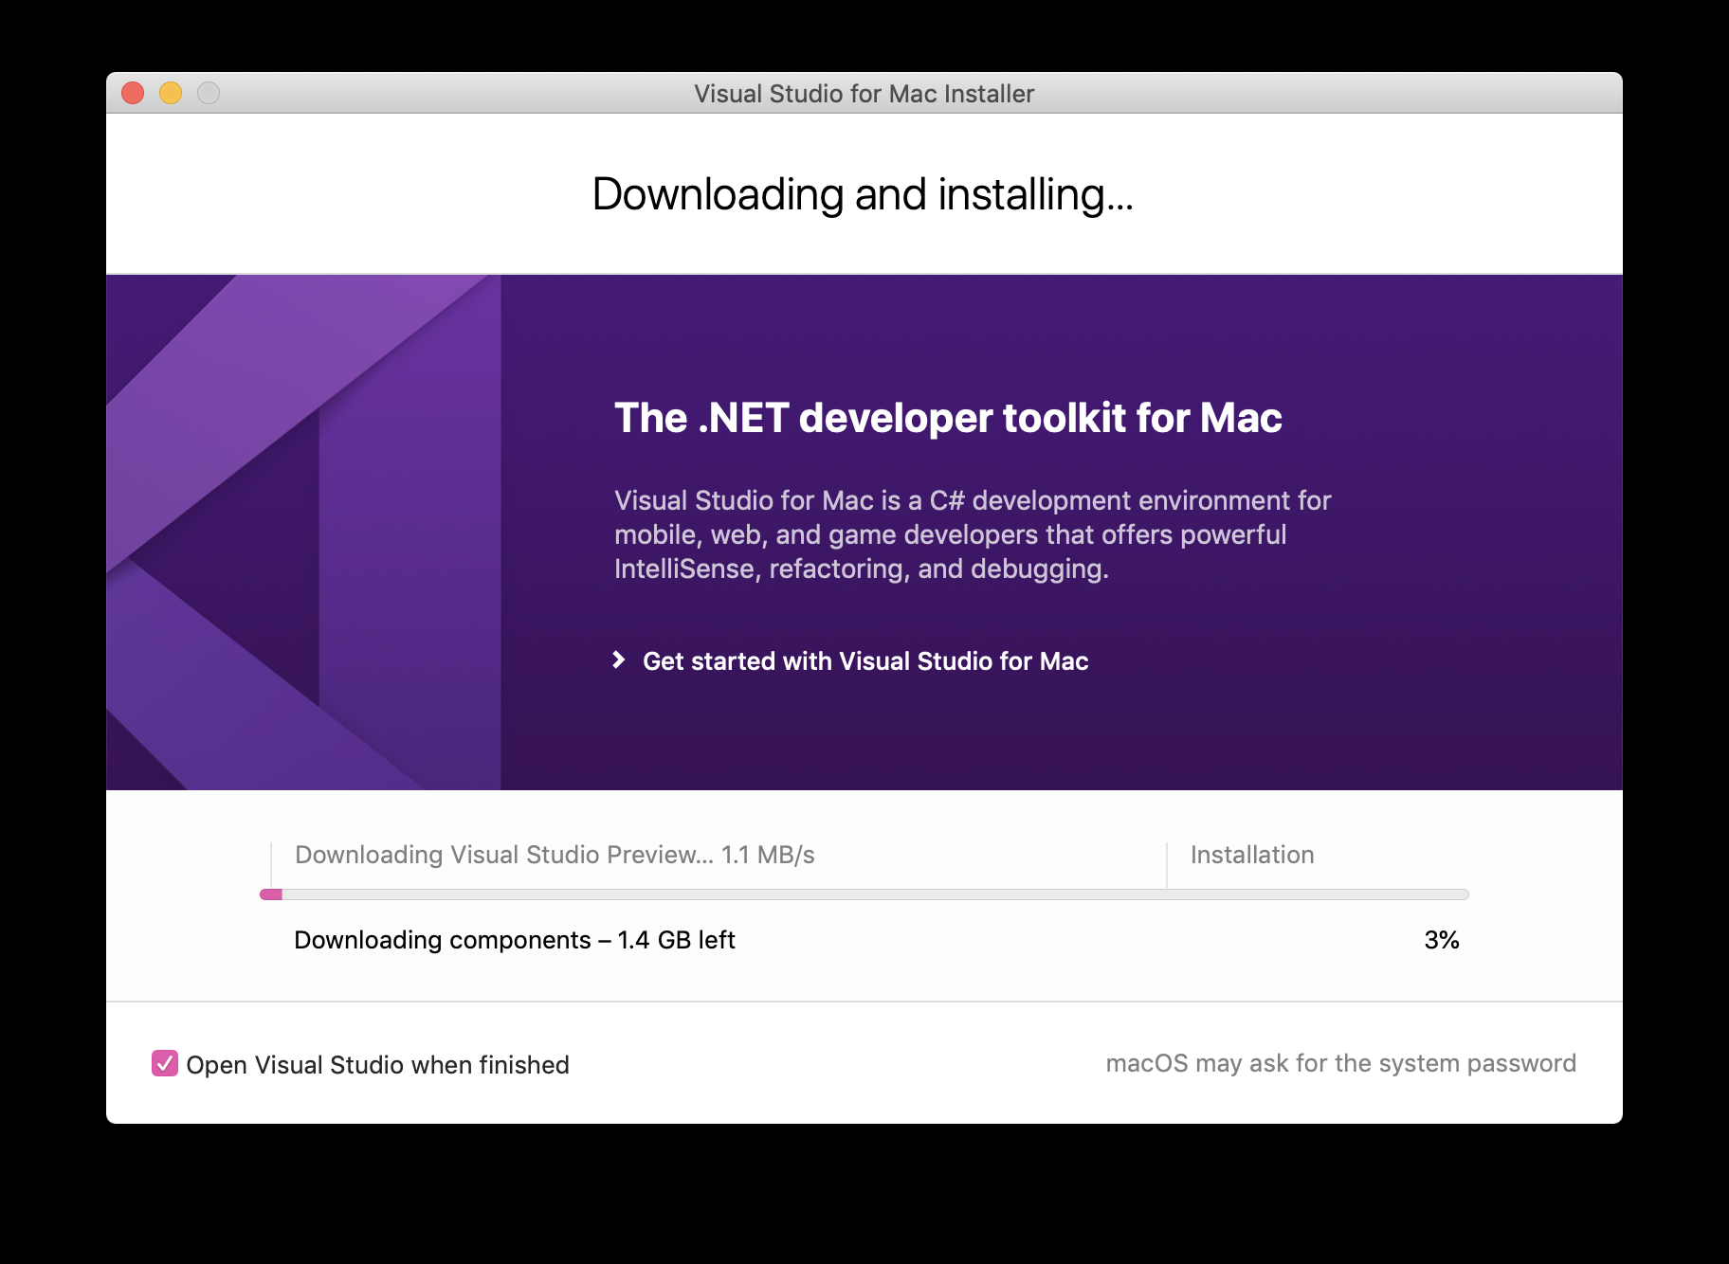

**Additional VS installation tutorial**

* Execute Automation. (2019). Installing and working with Visual Studio 2019 for MacOS.

<https://www.youtube.com/watch?v=DS4zGjyo4Zs>

### ENJOY CODING 😄 ###